**Quiz-4**

Answer **ALL** the questions Total marks - 20

1. Explain any four differences between image enhancement and image restoration with an example. **(4 marks)**
2. Image enhancement makes a picture look better, without regard to how it really truly should look. For example, brightening an image.

Image restoration tries to fix the image to get back to the real, true image.

For example, removing noise of an image.

1. Image enhancement means improving the image to show some hidden details.

For example, sharpening an image, making it easier to identify key features.

Image restoration means improving the image to match the original image.

For example, deconvolution an image.

1. Image enhancement is a purely subjective processing technique.

For example, it includes gray level and contrast manipulation, noise reduction, edge sharpening, filtering, interpolation and magnification, and pseudo coloring. Image enhancement techniques can be divided into two categories: frequency domain methods and spatial domain methods.

Image restoration is an objective process.

For example, it aims at a specific goal like removal of blur in an image by means of a deblurring function.

1. Image enhancement is a cosmetic procedure.

For example, it does not add any extra information to the original image. It merely improves the subjective quality of the images by work in with the existing data.

Restoration tries to reconstruct by using a prior knowledge of the degradation phenomena. Restoration hence deals with getting an optimal estimate of the desired result.

For example, restoration techniques are oriented towards modelling the degradation and applying the inverse process in order to recover the original image.

1. Write down any three different noise models and their source in real world applications. **(3 marks)**
2. Gaussian Noise Model.

For example, in telecommunications and computer networking, sensor or electronic circuit noise in amplifiers or detectors arises from natural sources such as thermal vibrations of atoms and discrete nature of radiation of warm objects caused by poor illumination and/or high temperature affects communication channels.

1. Uniform Noise Model.

For example, quantization noise caused by quantizing the pixels of a sensed image to a number of discrete levels, modelling noise in random number generation, simulation.

1. Rayleigh Noise Model.

For example, modelling noise in range imaging (distance fields).

## Write your answer here

1. Write down pseudocode for Adaptive Median Filter **(4 marks)**

Zmin = minimum intensity value in Sxy.

Zmax = maximum intensity value in Sxy.

Zmed = median of intensity values in Sxy.

Zxy = intensity at coordinate (x,y).

Smax = maximum allowed size of Sxy.

Level A:

1. If Zmin < Zmed < Zmax, go to Level B.
2. Else, increase the size of Sxy.
3. If Sxy <= Smax, repeat level A.
4. Else, output Zmed.

Level B:

1. If Zmin < Zxy < Zmax, output Zxy.
2. Else, output Zmed.

## Write your answer here

1. Given the pixel distribution of an image:

11

01

10

00

**r_k**

**p (r_k)**

**Huffman Code**

85

0.2

99

0.27

120

0.21

227

0.32

Remaining 0

* 1. Compute the variable length codes for each intensity using Huffman coding **(5 marks)**
  2. Compute the average length of bits required when we use (a) fixed length and (b) variable length codes that you obtained from (a). **(2+2 = 4 marks)**

b)

Fixed Length:

Average Length = 0.32(8) + 0.27(8) + 0.21(8) + 0.2(8)

= 8 bits

Variable Length:

Average Length = 0.32(2) + 0.27(2) + 0.21(2) + 0.2(2)

= 2 bits

Write your answer here

a

# --------------------------Rough Work Sheet-------------------------------

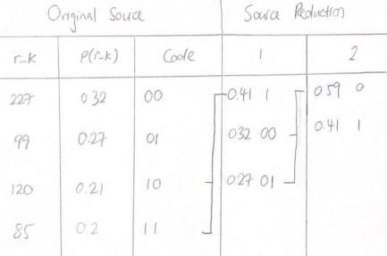 **(Do not detach it)**

4a) Huffman Coding Working

# --------------------------Rough Work Sheet-------------------------------

**(Do not detach it)**

# --------------------------Rough Work Sheet-------------------------------

**(Do not detach it)**